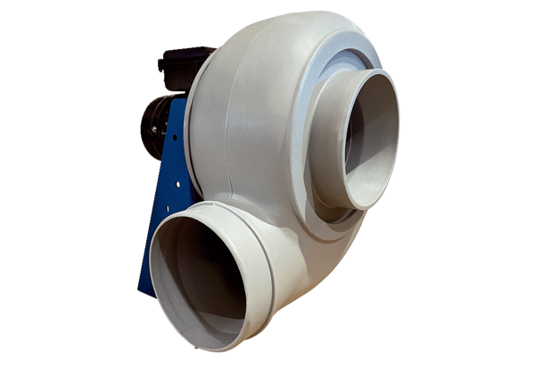Centrifugal blower GRK R 28/4 DPacking unit: 1 pieceRange: C
Article number: 0073.0517Manufacturer: MAICO

