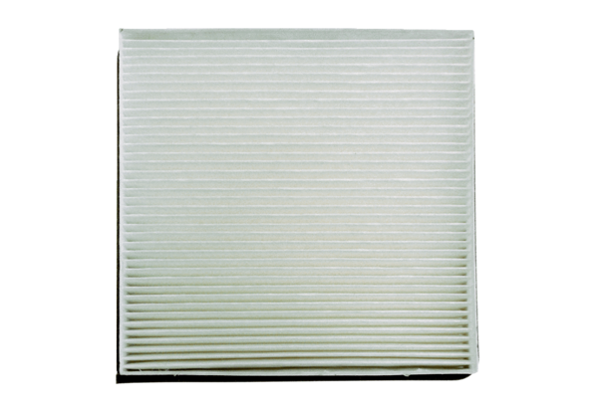Air filter, replacement PF 10/16Packing unit: 1 pieceRange: D
Article number: 0093.0698Manufacturer: MAICO

