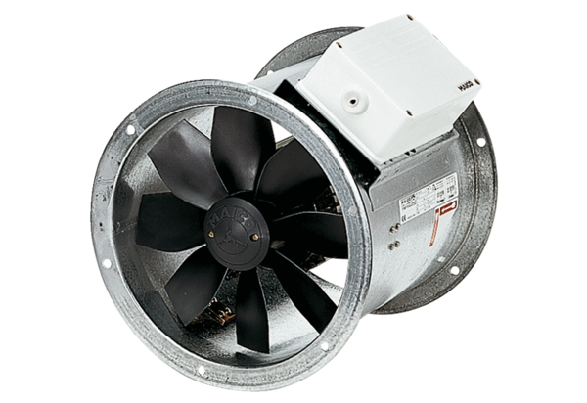Axial duct fan DZR 50/84 BPacking unit: 1 pieceRange: C
Article number: 0086.0052Manufacturer: MAICO

