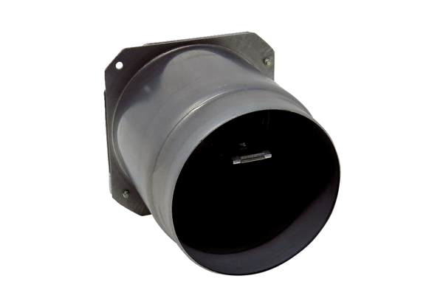Exhaust socket with pre-assembled backflow preventer ABSM RK ER-UPD/-UPB<data>
<p class="FT">Range:</p>
</data>
B
<data>
<p class="FT">Article number:</p>
</data>
E093.0977.0001<data>
<p class="FT">Manufacturer:</p>
</data>
MAICO

