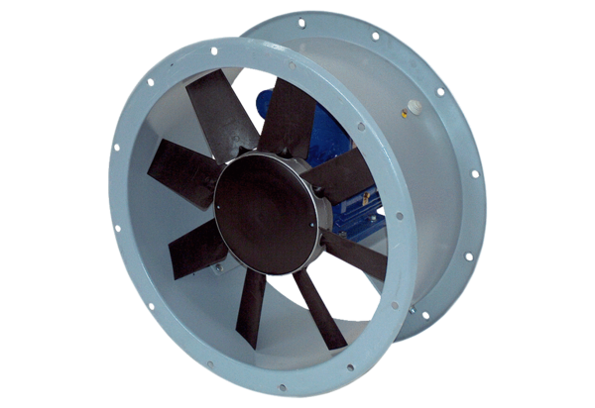Axial duct fan DAR 90/6-3 ExPacking unit: 1 pieceRange: C
Article number: 0073.0368Manufacturer: MAICO

