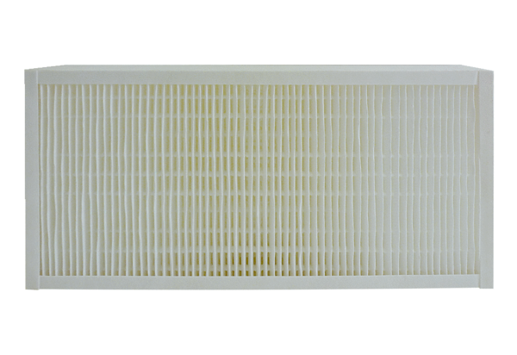Air filter, replacement KFF 6030-7Packing unit: 1 pieceRange: K
Article number: 0093.1218Manufacturer: MAICO

