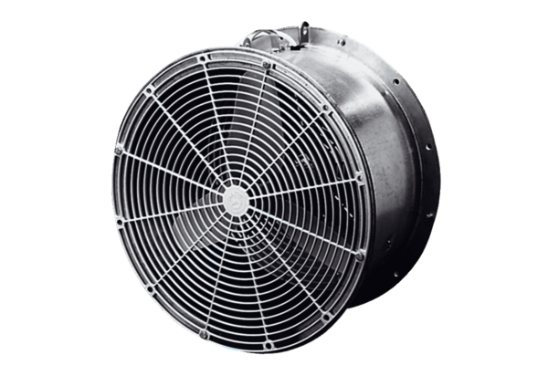Greenhouse fan EFG 20 EPacking unit: 1 pieceRange: C
Article number: 0081.0401Manufacturer: MAICO

