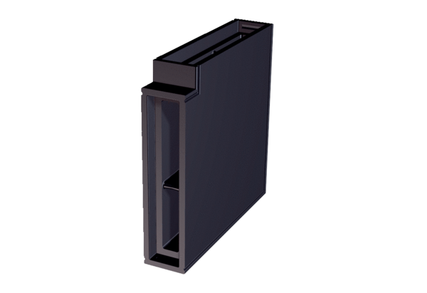Soffit element bracket PP 45 LEW90Packing unit: 1 pieceRange: K
Article number: 0093.1558Manufacturer: MAICO

