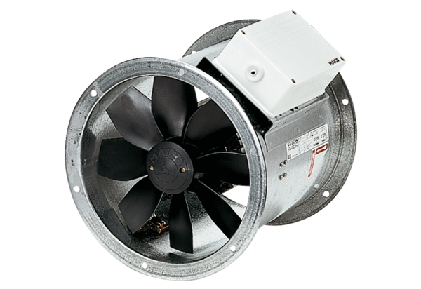Axial duct fan DZR 60/86 BPacking unit: 1 pieceRange: C
Article number: 0086.0069Manufacturer: MAICO

