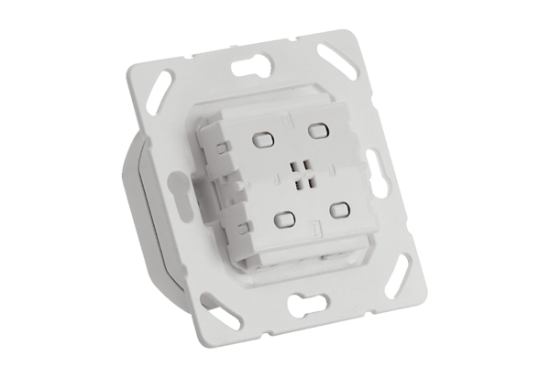EnOcean actuator PP 45 ACTPacking unit: 1 pieceRange: K
Article number: 0157.1445Manufacturer: MAICO

