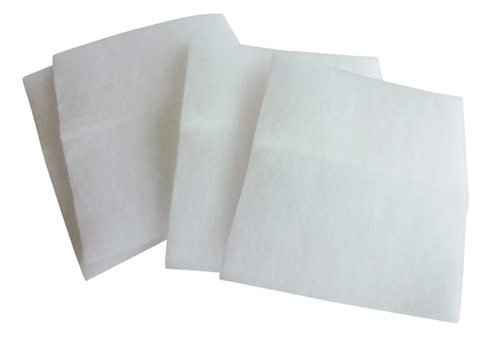Air filter, replacement WSG 600-1Packing unit: 4 piecesRange: K
Article number: 0093.0688Manufacturer: MAICO

