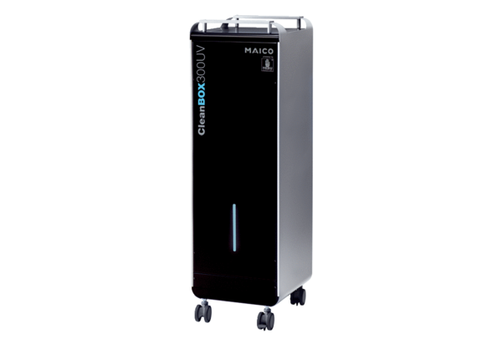Air purifier CleanBox 300 UVPacking unit: 1 pieceRange: L
Article number: 0095.0651Manufacturer: MAICO

