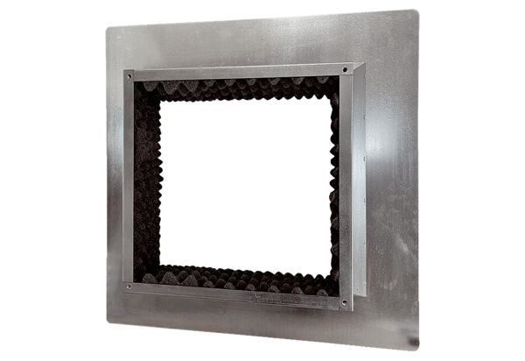Roof socket insulated, for flat roofs SOFI 50-56Packing unit: 1 pieceRange: C
Article number: 0073.0050Manufacturer: MAICO

