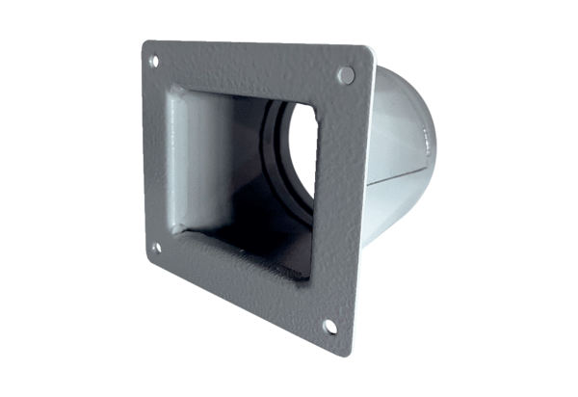Transition adapter URRI 14Packing unit: 1 pieceRange: C
Article number: 0073.0299Manufacturer: MAICO

