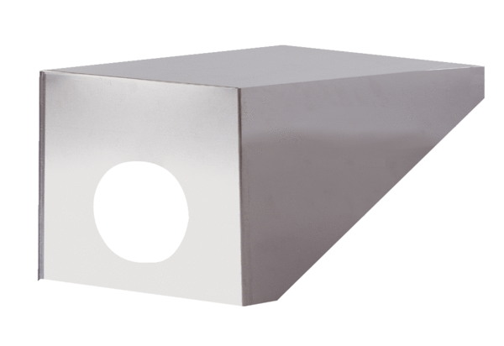Roof cowl PP 45 DH 25-30Packing unit: 1 pieceRange: K
Article number: 0093.1318Manufacturer: MAICO

