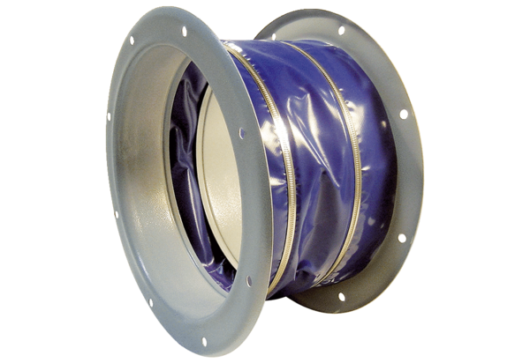Flexible coupling ELI 71Packing unit: 1 pieceRange: C
Article number: 0073.0219Manufacturer: MAICO

