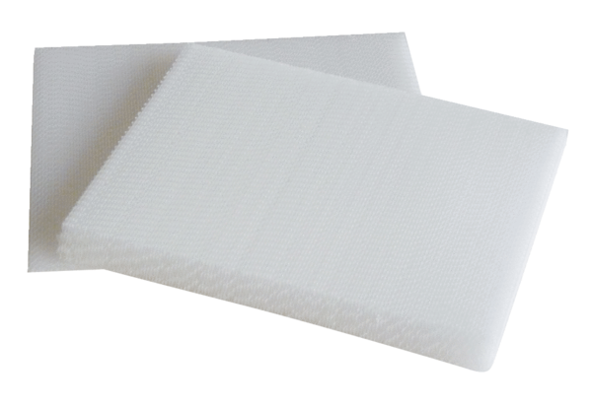Air filter, replacement WRG 35-G4Packing unit: 2 piecesRange: K
Article number: 0192.0452Manufacturer: MAICO

