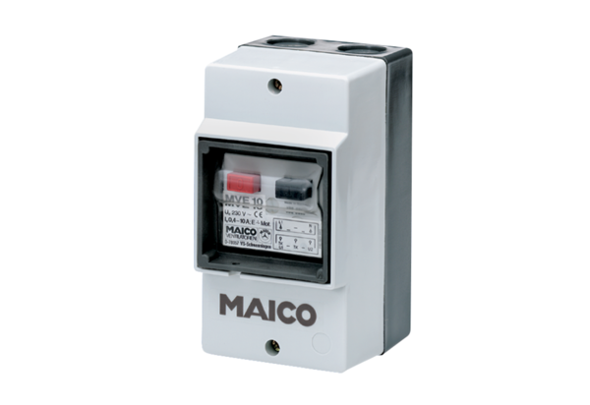Motor protection switch MVE 10Packing unit: 1 pieceRange: D
Article number: 0157.0711Manufacturer: MAICO

