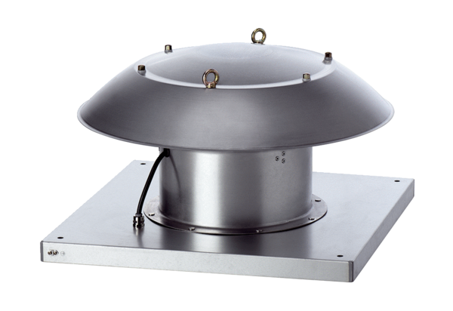Axial roof fan DZD 30/6 B Ex tPacking unit: 1 pieceRange: C
Article number: 0087.0812Manufacturer: MAICO

