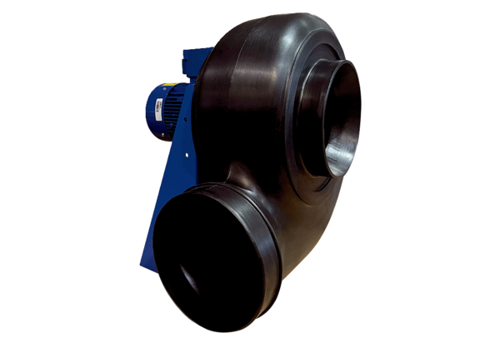Centrifugal blower GRK R 40/4 D ExPacking unit: 1 pieceRange: C
Article number: 0073.0452Manufacturer: MAICO

