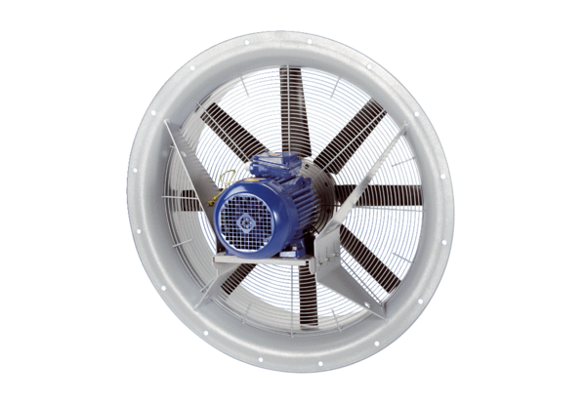Axial fan DAS 71/8Packing unit: 1 pieceRange: C
Article number: 0083.0851Manufacturer: MAICO

