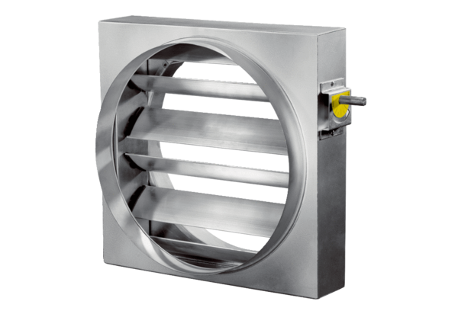Control shutter JRE 50Packing unit: 1 pieceRange: C
Article number: 0151.0394Manufacturer: MAICO

