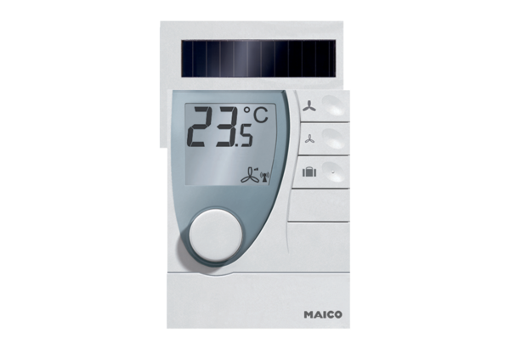Room air control RLS RCPacking unit: 1 pieceRange: A
Article number: 0157.0849Manufacturer: MAICO

