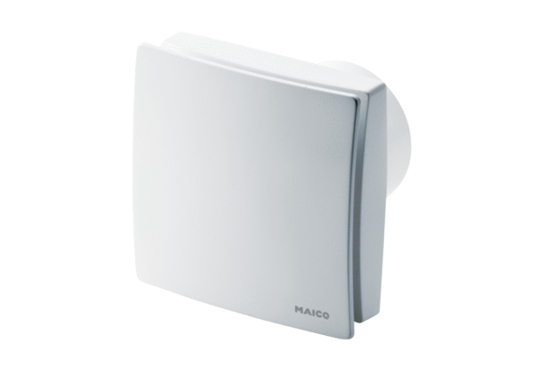Small room fan ECA 150 ipro RCPacking unit: 1 pieceRange: A
Article number: 0084.0087Manufacturer: MAICO

