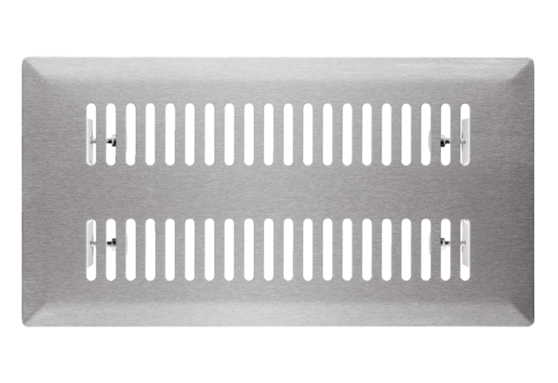Floor grille FFS-FGPacking unit: 1 pieceRange: K
Article number: 0055.0889Manufacturer: MAICO

