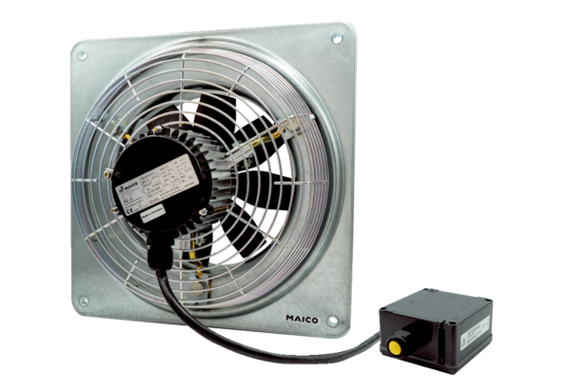Axial wall fan DZQ 25/4 B Ex tPacking unit: 1 pieceRange: C
Article number: 0083.0202Manufacturer: MAICO

