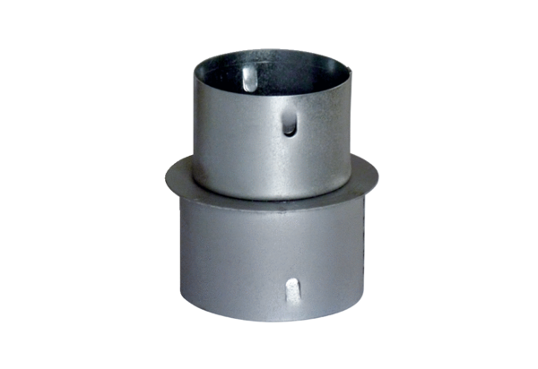Reducer MF-RZ75/63Packing unit: 1 pieceRange: K
Article number: 0018.0072Manufacturer: MAICO

