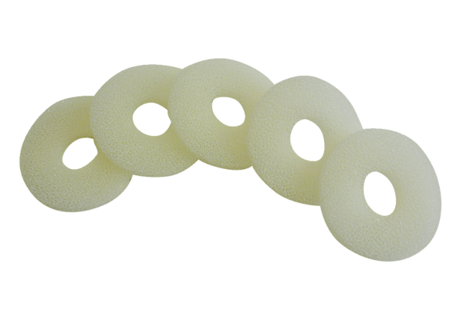Air filter, replacement ALDF 10 TPacking unit: 5 piecesRange: B
Article number: 0093.0155Manufacturer: MAICO

