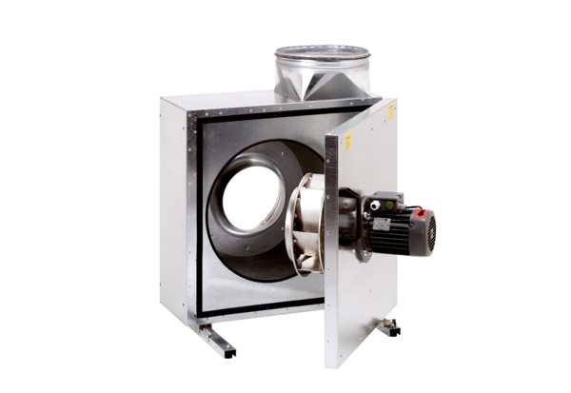Sound-insulated ventilation box EKR 25-2Packing unit: 1 pieceRange: C
Article number: 0080.0883Manufacturer: MAICO

