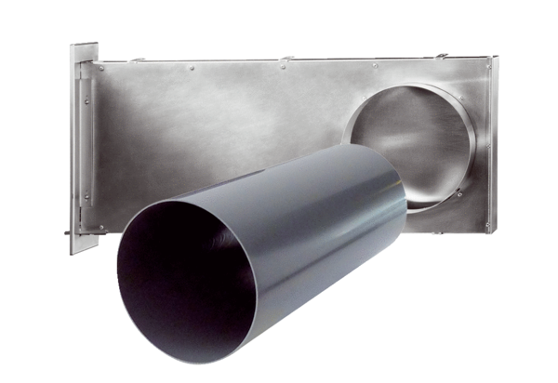Shell kit PP 60 KL-SRPacking unit: 1 pieceRange: K
Article number: 0095.0206Manufacturer: MAICO

