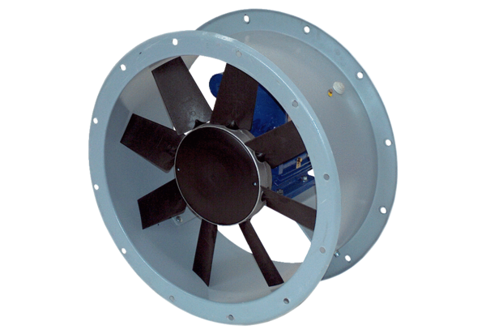Axial duct fan DAR 90/6 3Packing unit: 1 pieceRange: C
Article number: 0073.0162Manufacturer: MAICO

