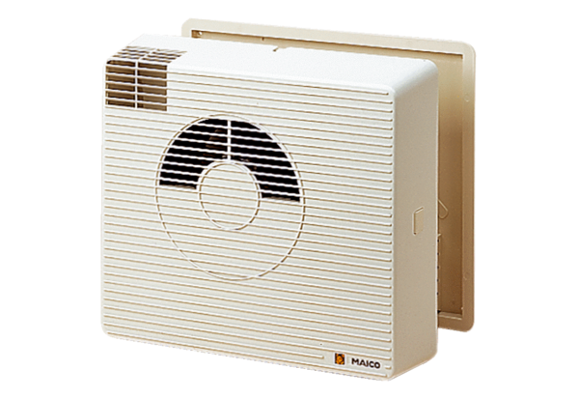Heat recovery unit WRG 20-2Packing unit: 1 pieceRange: D
Article number: 0082.0225Manufacturer: MAICO

