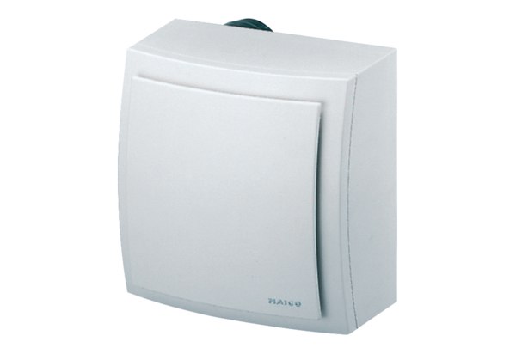Surface-mounted fan ER-AP 60 GPacking unit: 1 pieceRange: B
Article number: 0084.0153Manufacturer: MAICO

