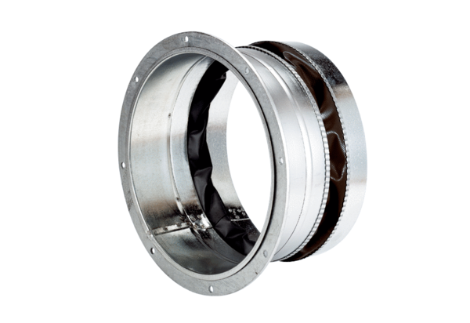Flexible coupling ELA 25 ExPacking unit: 1 pieceRange: C
Article number: 0092.0275Manufacturer: MAICO

