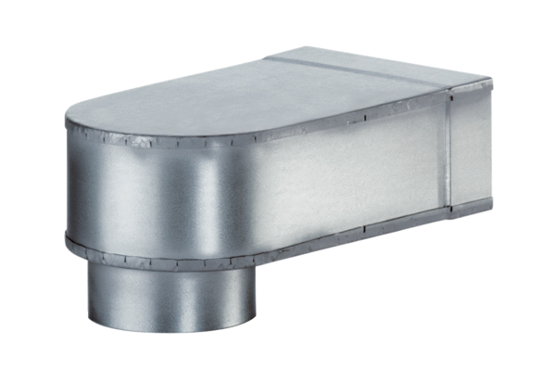Bracket MF-W150 80/200Packing unit: 1 pieceRange: K
Article number: 0018.0496Manufacturer: MAICO

