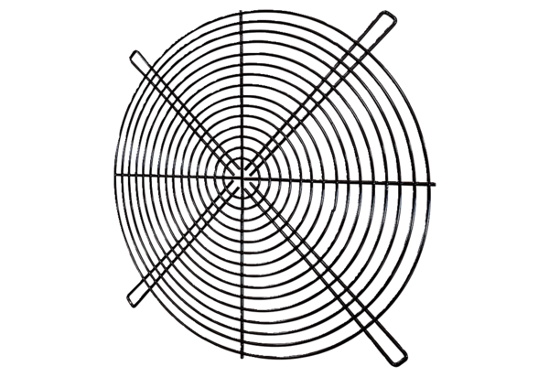Protective grille SGRI 40Packing unit: 1 pieceRange: C
Article number: 0073.0423Manufacturer: MAICO

