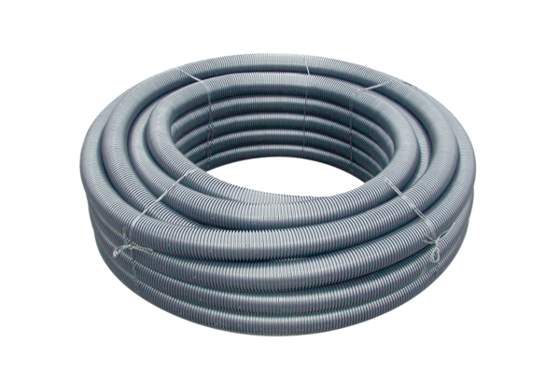Flexible duct MF-F63Range: K
Article number: 0055.0097Manufacturer: MAICO

