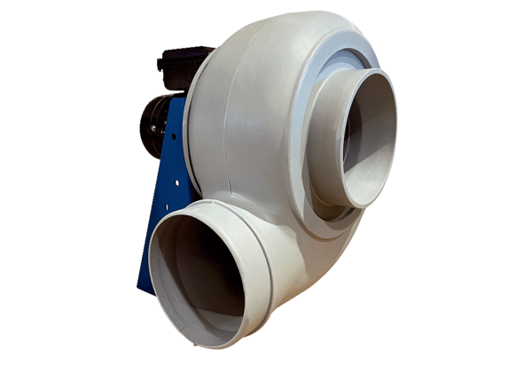Centrifugal blower GRK R 31/2 DPacking unit: 1 pieceRange: C
Article number: 0073.0518Manufacturer: MAICO

