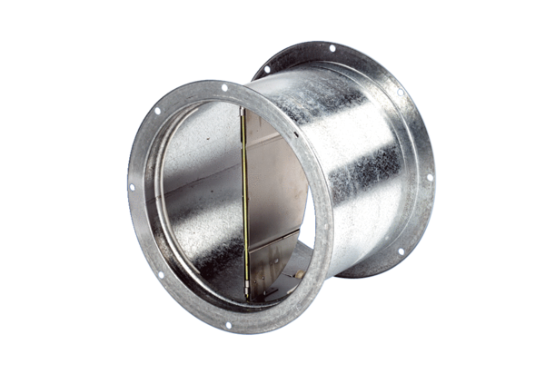Shutter, pull device VD 25Packing unit: 1 pieceRange: C
Article number: 0093.0101Manufacturer: MAICO

