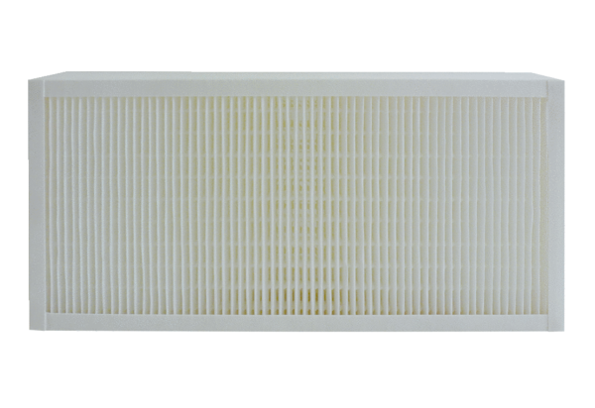Air filter, replacement KFF 6030-5Packing unit: 1 pieceRange: K
Article number: 0093.1215Manufacturer: MAICO

