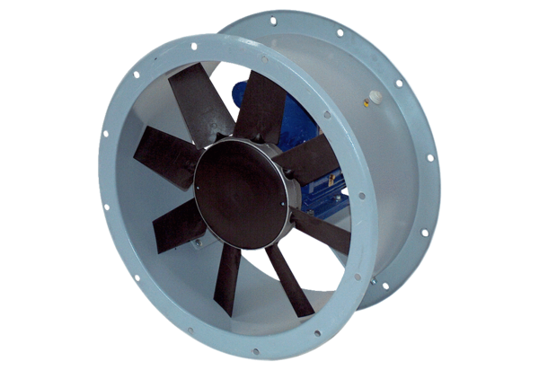Axial duct fan DAR 160/8 11Packing unit: 1 pieceRange: C
Article number: 0073.0199Manufacturer: MAICO

