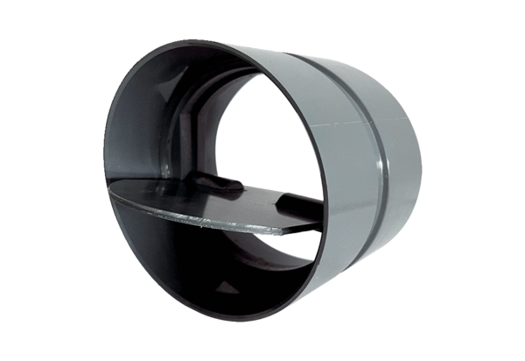Shutter VKKI 28Packing unit: 1 pieceRange: C
Article number: 0073.0474Manufacturer: MAICO

