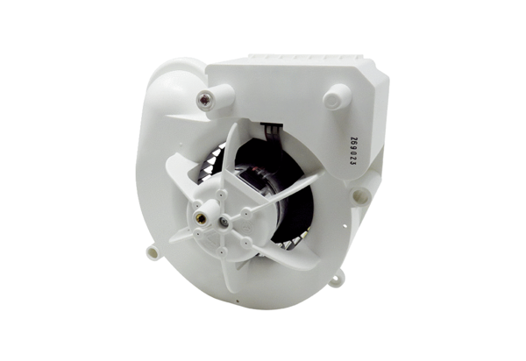Fan insert VE ER-APB 100 FRange: B
Article number: E084.0178.0000Manufacturer: MAICO

