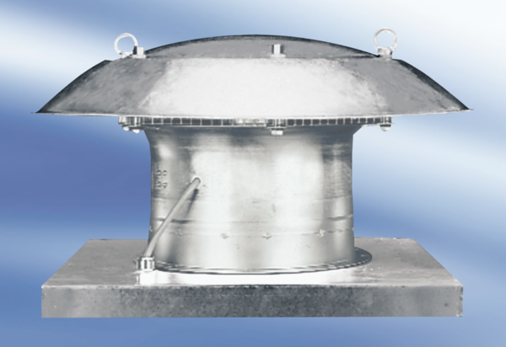Axial roof fan DZD 35/4 A-ExPacking unit: 1 pieceRange: C
Article number: 0087.0771Manufacturer: MAICO

