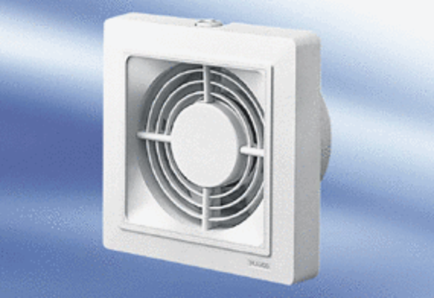Small room fan ECA 15/4 FPacking unit: 1 pieceRange:
Article number: 0080.0977Manufacturer: MAICO

