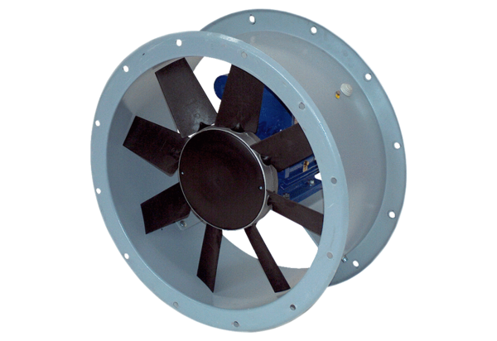Axial duct fan DAR 90/8-2 ExPacking unit: 1 pieceRange: C
Article number: 0073.0370Manufacturer: MAICO

