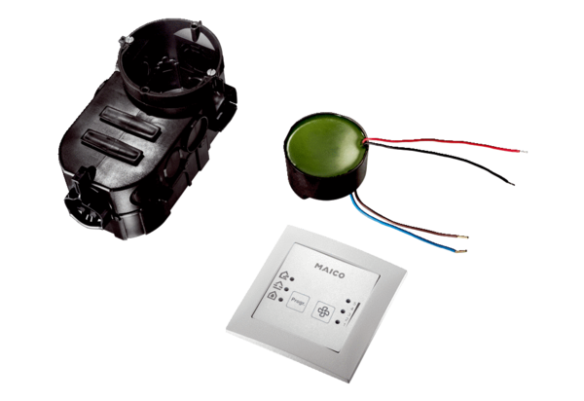Room air control RLS PP-K1Packing unit: 1 pieceRange: K
Article number: 0157.0193Manufacturer: MAICO

