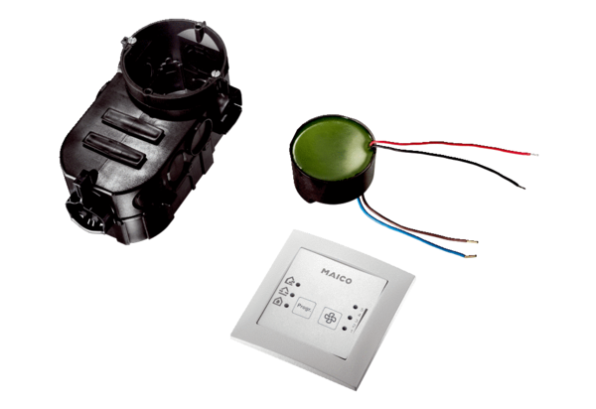Room air control RLS PP-KPacking unit: 1 pieceRange: K
Article number: 0157.0199Manufacturer: MAICO

