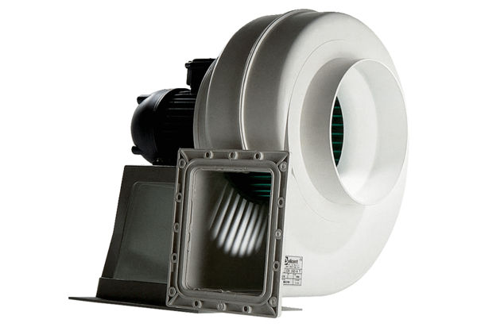Centrifugal blower GRK 16/4 DPacking unit: 1 pieceRange: C
Article number: 0073.0305Manufacturer: MAICO

