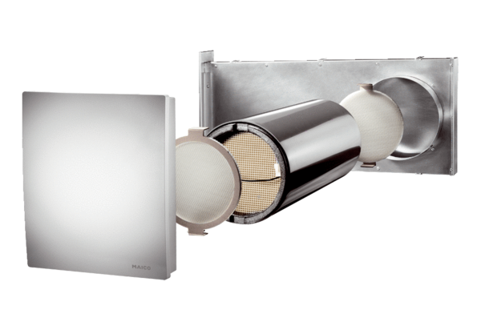Complete set PP 60 KLPacking unit: 1 pieceRange: K
Article number: 0095.0203Manufacturer: MAICO

